The central goal of paleoclimate research is enhanced knowledge climatic conditions constructing records of past temperature, precipitation, etc. In the dendrochronology community, annual reconstructions of past climate consist of “estimates” of a particular climate variable, eg. July-September air temperature. These estimates are based on a calibration relationship between the tree-ring record and the measured temperature over an interval when both records are available. The calibration transforms the tree-ring record into equivalent temperature units, providing estimates of temperature in both the period in which the two records overlap as well as back in time before temperatures were measured with human instruments. In each year of the calibration interval, the difference between the measured air temperature and the estimated value can be measured. Reconstructions often display confidence intervals in the calibration period, for example a band around the reconstruction estimates that envelopes 90% of the measured instrumental values. In the time period prior to instrumental measurement data, an analogous band called the prediction interval is often shown. In contrast to the simple nature of the confidence interval, in which the instrumental data values are known, prediction intervals must be estimated based on the relationship between the reconstruction and instrumental target in the interval of data overlap.

**TreeNob RCS Chronology**

Trad

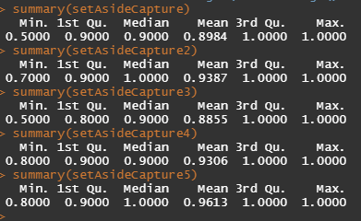

MEboot

**TNSimul2 (random sampled correlation-ascending-ordered surrogates 9000-1000)**

TRAD

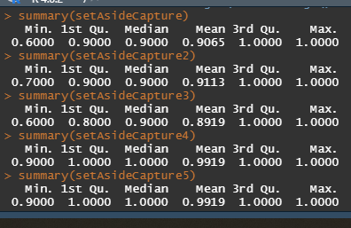

MEboot

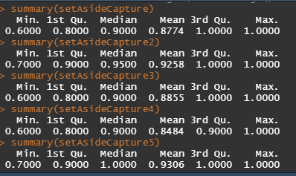

**TNSimul3 (random sampled correlation-ascending-ordered surrogates 8500-9500)**

TRAD

MEboot

**TNSimul5 (random sampled correlation-ascending-ordered surrogates 7500-8500, r=0.68)**

Trad

MEboot

